Convergence of the maximum of a sample from a Uniform distribution

**Objective:** The primary purpose is to explore the convergence of $X_{\left(n\right)}$ for the Uniform distribution as the sample size ($n$) increases.

**Task:** Follow the subsequent steps to examine the convergence of $X_{\left(n\right)}$:

1. Open the Shiny app given in the URL:

<http://gauss.medellin.unal.edu.co:3838/fhernanb/convergencia1>

1. Using the Shiny app, select the Uniform distribution, the sample size ($n$), the population maximum ($γ$) and $ϵ$ based on the information given in Table 1.
2. In Table 1, fill the gaps by using the results from the Shiny app in order to infer curves on Figure 1 (convergence quickness of $X_{\left(n\right)}$) with their respective colors which are associated to each distinct value of $ϵ$.

Table 1. Assessment of $F_{X_{\left(n\right)}}\left(γ-ϵ\right)$ as $n$ increases.

|  |  |  |  |  |  |  |
| --- | --- | --- | --- | --- | --- | --- |
|  |  |  |  |  |  |  |
|  |  |  |  |  |  |  |
|  |  |  |  |  |  |
|  |  |  |  |  |  |

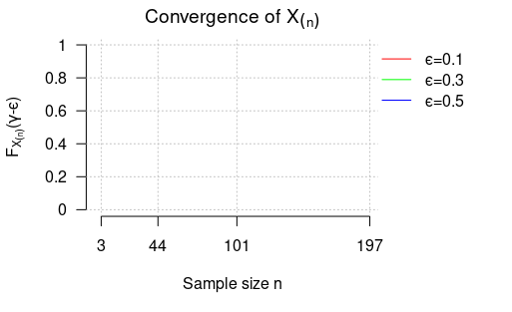

Figure 1. Template to illustrate the convergence swiftness of $X_{\left(n\right)}$ for each distinct value of $ϵ$.

1. In accordance with Table 1 and Figure 1:

* What can be inferred with regard to the pattern observed?

________________________________________________________________________________________________________________________________________________________________________________________________________________________________________________________________________________________________________________________________________________________________________

* It can be affirmed that $X_{\left(n\right)}$ is close to $γ=8.6$ with high probability (when $n$ is large)?

________________________________________________________________________________________________________________________________________________________________________________________________________________________________________________________________________________________________________________________________________________________________________

* What can be concluded about the convergence quickness of $X_{\left(n\right)}$ as $ϵ$ rises?

________________________________________________________________________________________________________________________________________________________________________________________________________________________________________________________________________________________________________________________________________________________________________

Convergence of the minimum of a sample from a Shifted Exponential distribution

**Objective:** The primary purpose is to explore the convergence of $X_{\left(1\right)}$ for the Shifted Exponential distribution as the sample size ($n$) increases.

**Task:** Follow the subsequent steps to examine the convergence of $X_{\left(1\right)}$:

1. Open the Shiny app given in the URL <https://tinyurl.com/shinyconv>.
2. Using the Shiny app, select the Shifted Exponential distribution, the sample size ($n$), the population minimum ($γ$) and $ϵ$ based on the information given in Table 2.
3. In Table 2, fill the gaps by using the results from the Shiny app in order to infer curves on Figure 2 (convergence quickness of $X_{\left(1\right)}$) with their respective colors which are associated to each distinct value of .

|  |  |  |  |  |  |  |
| --- | --- | --- | --- | --- | --- | --- |
|  |  |  |  |  |  |  |
|  |  |  |  |  |  |  |
|  |  |  |  |  |  |  |
|  |  |  |  |  |  |  |

Table 2. Assessment of $F_{X_{\left(1\right)}}\left(γ+ϵ\right)$ as $n$ increases.

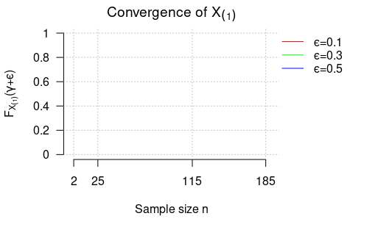

Figure 2. Template to illustrate the convergence swiftness of $X_{\left(1\right)}$ for each distinct value of $ϵ$

1. In accordance with Table 2 and Figure 2:

* What can be inferred with regard to the pattern observed?

________________________________________________________________________________________________________________________________________________________________________________________________________________________________________________________________________________________________________________________________________________________________________

* It can be affirmed that $X_{\left(1\right)}$ is close to $γ=4.2$ with high probability (when is large)?

________________________________________________________________________________________________________________________________________________________________________________________________________________________________________________________________________________________________________________________________________________________________________

* What can be concluded about the convergence quickness of as rises?

________________________________________________________________________________________________________________________________________________________________________________________________________________________________________________________________________________________________________________________________________________________________________